Contents
Unfunded Agreements 2
Create Proposal Screen 4
Proposal Details Screen 5
Key Personnel Screen 6
PI Compliance Questionnaire 6
Questionnaire Screen 7
Compliance Screen 9
Exhibit A – Confidentiality /Non-Disclosure Agreements (CDA/NDAs) 14
Exhibit B – Data Use Agreement (DUA)/Data Transfer Use Agreement (DTUA) 16
Exhibit C - Software Loan Agreement 18
Exhibit D - Equipment Loan Agreement 20
Exhibit E – Material Transfer Agreement 22
Exhibit F – Memorandum of Understanding/Letter of Agreement 24
Exhibit G – Teaming Agreement 25
Exhibit H – Unfunded Collaboration Agreement 26

Unfunded Agreements

The agreement is considered “unfunded” if no money will be directly transferred under it (ie. not a “sponsored” research agreement). It can be tied to a current or future sponsored research agreement, such as a NIH-funded project, but if no money is changing hands under this agreement, the request should be submitted as an “unfunded.”
Please note that the KR PD record for unfunded requests asks different questions than for funded requests, specifically in the PI Compliance Questionnaire and Questionnaire tabs. Further, the Anticipated Agreement Type MUST be “Unfunded Agreement” to route to the correct team.
The Sponsored Projects Office reviews, negotiates, and signs unfunded agreements for research activities and incoming General Campus services only.
For Confidentiality Agreement/Non-Disclosure Agreement: OCGA handles CDAs for research activities (ex. initial discussions for a future research collaboration) and General Campus incoming services only. Other UCSD offices also manage CDAs for activities under their purview:

- CDAs for or related to an Industry-Initiated Clinical Study (including non-interventional studies) are handled by the Office of Clinical Trial Administration (OCTA). Please submit the CDA for OCTA’s review through their jotform. Please contact OCTA at octa@ucsd.edu for additional guidance.

- CDAs related to incoming service agreements for Health Science departments (UCSD is paid to perform a service) are managed by Health Sciences Business Contracting (HS BC).

- CDAs related to outgoing services agreements (UCSD is paying a vendor to perform a service) or is in anticipation of a procurement of services (ex. to get a vendor’s quote) are handled by IPPS/Procurement. Please submit the CDA for IPPS’ review through Oracle. To access Oracle Financials Cloud visit ofc.ucsd.edu, click the Company Single Sign-On button, then log in with your Active Directory information are managed by Procurement/IPPS.

- CDAs related to an intellectual property license agreement are managed by the Office of Innovation and Commercialization.

- *IMPORTANT* - Create and route one KR PD record for each agreement. Ex. If you need a Data Use Agreement and a Service Agreement for the same project, please submit one KR PD record for each.

Login into Kuali using your Business Systems ID or Active Directory login and password. If you do not have access to Kuali Research, navigate to the end of this training guide for detailed instructions or click on the following link: Requesting Kuali Access.

NOTE: PI’s requesting access should request the role of Department Proposal Creator.

- Click on Research Home

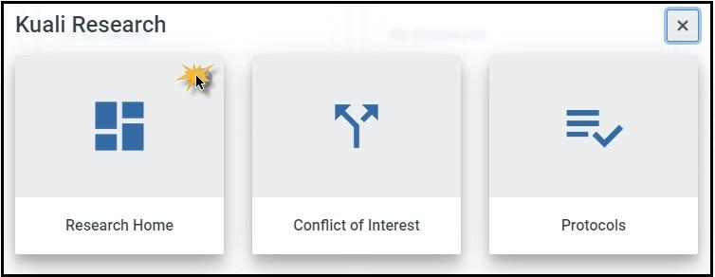

- From the left-hand navigation:
  - Click on Common Tasks
  - Click on Create Proposal in the Proposal Development Card

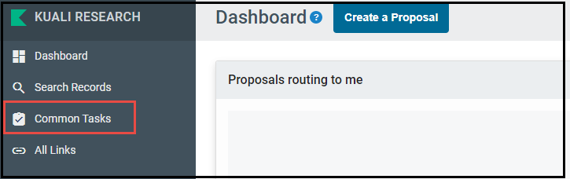

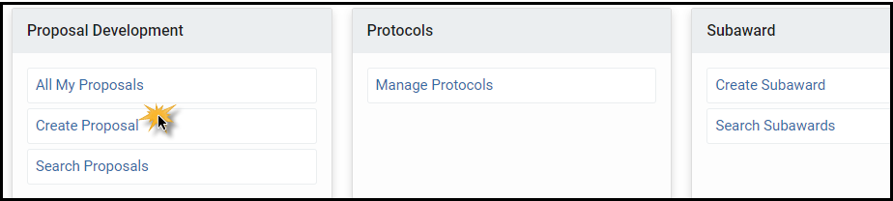

Create Proposal Screen
NOTE: No other available Proposal Type options are applicable to Unfunded Agreements
- Proposal Type: from the dropdown menu:
  - New (if it is a new agreement) or
  - Continuation (if it is an amendment to an existing Unfunded Agreement)

- Lead Unit: Select the Lead Unit from the dropdown menu. (You may have multiple options if you are a Department Research Administrator or proposal creator for more than 1 department).
NOTE: For unfunded agreements, “Sponsor” means the other entity. It does not mean a financial sponsor or regulatory sponsor.

Multi-party agreements: If this agreement will be among multiple parties (UCSD, the entity already entered in the Sponsor field, plus additional entities), you will add the additional parties to the agreement in the Unfunded Agreement tab of the Questionnaire Section.

- Activity Type: Select Other Sponsored Activities from the dropdown menu.

- Project Dates: Enter the project Start and End dates (estimates are okay).

- Project Title: Enter the Project title and Agreement type if available: (Example: A Retrospective Chart Review of Late-Stage Hematological Malignancies DUA).

- Sponsor Field: Enter the entity with which UCSD is entering into the agreement- Several options are available to search for the sponsor:
  - Start typing the name of the entity/sponsor directly into the field.
  - Click on the magnifying glass at the end of the field and type in the name of the entity/sponsor in the Sponsor Name field using an asterisk* to narrow your search results (example: *Cornell*) and click on Search at the bottom of the Sponsor Lookup screen. All results with Cornell in the name will appear, allowing you to select the appropriate entity/sponsor.

If you are unable to locate the sponsor code:
  - Enter 9850 Sponsor Code Pending in the Sponsor field.
  - After you have successfully entered the remaining information on the Create Proposal Screen, navigate to the Attachments section. In the Notes section enter the name of the sponsor, physical address and website address for the new entity/sponsor to be created. A notification will be sent to OCGA for a new sponsor to be created.
- Sponsor Deadline: Enter the date six months out from today’s date (ex. if you are creating this record on 3/1/24, use 9/1/24 as the Sponsor Deadline date). A date 6 months out is UCSD’s standard method of notifying the central office that the agreement is available for review (“internal proposal”); it does not indicate the project end date or that it will take 6 months to negotiate the agreement.
NOTE: No other available Proposal Type options are applicable to Unfunded Agreements
  - The ONLY exception to this is for urgent NDAs for discussions where a meeting date and time has already been agreed to. In this unusual circumstance, enter the meeting date as the Sponsor Deadline date AND attach proof of the scheduled meeting date with rationale (ex. email from agency or non-UCSD entity) in the Attachments tab. The department is advised to do so sparingly.
  - OCGA will do its best to facilitate execution of the NDA by this date; however, execution is dependent upon many factors (ex. compliance offices review, other entity’s willingness to accept standard university contractual terms) and it is not guaranteed that the NDA will be executed by that date.

- Sponsor Deadline Type: Select Internal from the dropdown menu.

- Anticipated Agreement Type: Select Unfunded Agreement from the dropdown menu. NOTE: if another Agreement Type is incorrectly selected, this request will route to the wrong office/team and there will be delays in review.

- Click Save and Continue at the bottom of the screen.

Proposal Details Screen
The Unfunded Agreement record has been saved, a proposal number has been created and you are now on the Proposal Details Screen. Verify the information you have entered.

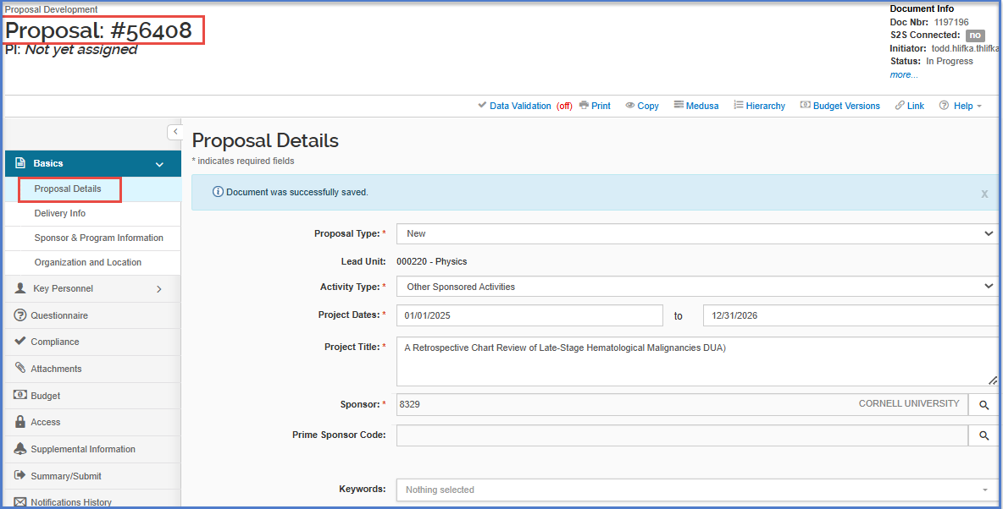
After verifying the information, click Save at the bottom of the screen and navigate to the Key Personnel Screen.
Note: Only UCSD employees should be listed as Key Personnel. Non-university employees (i.e. visiting scholars) and UC San Diego students will be listed in the Compliance Questionnaire.

Key Personnel Screen
In this section you will add the Principal Investigator (PI). Unlike proposals for funding, you do not need to add any Co-Investigator(s) or Key Personnel.
- Click on Personnel under Key Personnel.
- Click on Add Personnel and enter the Last Name of the PI (best practice is to use the asterisk (*) to narrow your search results) and then click Continue.
- Click the radio button next to the appropriate person and click on Continue.
Note: In the Human Research section de-identified data does not require oversight, but this does not mean that the Human Subjects question should be no as well. The HDOC (Health Data Oversight Committee) question is specific to outgoing UCSD data.

- Click on Add Person.
- After you have added the PI/Technical Lead, click on the blue “Notify” button next to the Principal Investigator’s name. This will send an electronic notification to the Principal Investigator to login to Kuali and answer the Compliance Questionnaire. As the Compliance Questionnaire requires certifications as to the accuracy of the answers, the PI should answer the Compliance Questionnaire. To view the Compliance Questionnaire, click on the arrow next to the PI Name and navigate to the Compliance Questionnaire tab and click to open.
- Click on Save and Continue at the bottom of the screen.

PI Compliance Questionnaire
These are questions answered by the PI. Questions include: Foreign Engagement, Human Research, Conflict of Interest, Animal Subjects and Export Control Questions and where non-UCSD employees (example: visiting scholars) and UCSD students will be added to the record, are answered.
The PI that is certifying must be a PI or Co-I on the applicable IRB Protocol if applicable.
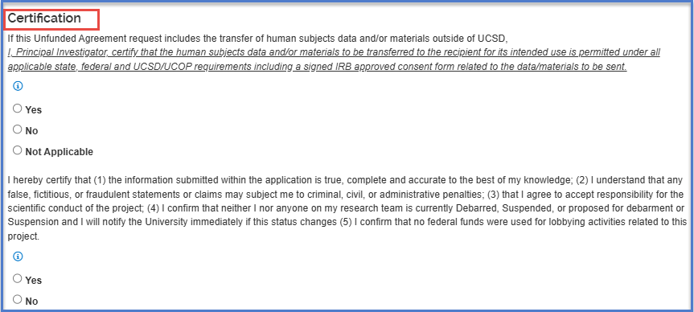

Questionnaire Screen
Note: If new space is being requested, the agreement will route to the department approvers (MSO/DBO and Chair) as part of critical criteria review.

NOTE: The contact must be from the other entity. Do not include UCSD personnel
Contact Tab: Enter the full name and email address for the authorized official/legal contact for the sponsor/entity UCSD will be negotiating with. Click on Save.
Navigate to the Space tab: select yes or no to the questions regarding on-campus and off-campus space based on the needs of the Unfunded Agreement only. You MUST answer “yes” to at least one of the questions.

Navigate to the Unfunded Agreement tab: In this tab you will answer additional questions relevant to your Unfunded Agreement.
You will need to check all boxes and complete all fields in this section. New required fields have been added to this section. Depending on “type” of agreement you choose, more questions may populate.
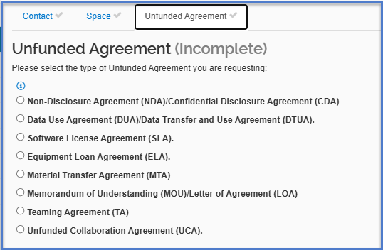
See the attached exhibits for additional guidance for the type of request that you are submitting. This section collects the minimum amount of information required for the Contract Officer to understand the project, and correct answers are critically important. If any of these answers are skipped or incorrectly answered, the review of the agreement will be significantly delayed. If you are completing the PD record on behalf of the PI and are unsure of the answers, please confirm with the PI prior to submitting.
In the Agreement Information section, be sure to correctly answer the question regarding other organizations or third parties involved in the research.
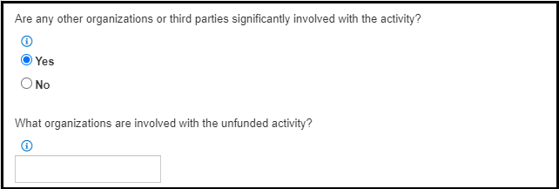
Some examples:
- UCSD is sharing data with Stanford, but the data was generated under Pfizer funding. List Pfizer as an organization.
- UCSD is receiving a piece of equipment from a company but will be using it with software from another company. List both companies.
If this agreement includes multiple parties, you will enter the additional parties to the agreement in the Comments and Supporting Documents section. Please enter the following information for all additional parties to the agreement:
- Legal Name of Entity
- Contact name
- Contact email
Click on Save and Continue.

Compliance Screen
In this section, you will add a compliance entry for each compliance question responded to with “yes” in the PI Compliance Questionnaire. For example, if the PI answered yes to the Human Research questions, you would add a compliance entry for Human Subjects. Note: if the PI answered “yes” to compliance questions in the PI Compliance Questionnaire, but no corresponding compliance entry is added on this screen, you will NOT be able to submit the KR PD record and will receive an Error.

1. Click on Add compliance entry.
- Select the Type from the dropdown menu.
- Select the appropriate Approval Status from the dropdown menu. If the compliance (ex. IRB) is approved, it should state “approved” and not “pending.”
- Click on Add Entry.
- Click on Save and Continue.

Attachments Screen
In this section you must upload the following documents in the Internal tab. Please note that these documents provide the minimum background information the Contract Officer needs to understand the project. If the Research Plan/Scope of Work/Protocol is still in development, please attach the latest draft.

For all Unfunded Agreements (including CDAs and MOUs): A Word document (preferred) or PDF version of the draft agreement. Note: if the other entity has not provided you with a draft agreement, there is no need to upload any agreements and OCGA will utilize a UCSD template. You can indicate that no agreement was provided to you in the Unfunded Agreement Questionnaire tab.

For all Unfunded Agreements except CDAs and MOUs:
- A Research Plan/Statement of Work/Scope of Work/Protocol that describes in detail the scientific/research activities that will be performed by all parties (this often includes a description of any data/materials that will be transferred, timelines, and deliverables/milestones)
- f human subjects research, the IRB approval letter or determination letter that the activity is not human subjects research (if applicable), Protocol, and “stamped” informed consent forms that were used at the time the study participant was consented, if available
- If animal subjects research, the IACUC approval letter, if available
- Any other relevant documentation (e.g., related agreements, such as executed contracts, grants, service agreements, or Purchase Orders; correspondence).

Attachments Specific to Material Transfer Agreements:

- For Receiving materials, the MTA Draft Agreement provided by the contracting entity.
- A Research Plan/Statement of Work/Scope of Work/Protocol that describes in detail the scientific/research activities that will be performed by all parties (this often includes a description of any data/materials that will be transferred, timelines, and deliverables/milestones).
- If animal subjects research, the IACUC approval letter, if available.
- Any other relevant documentation (e.g., related agreements, such as executed contracts, grants, service agreements, or Purchase Orders; correspondence).

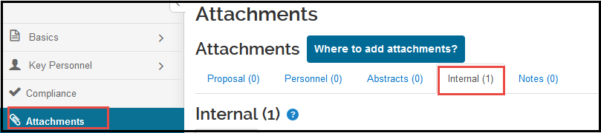

- Click on the Internal tab.
- Click on the +Add button.
- In the Type dropdown menu select Other Internal Documentation.
- In the Status dropdown select Draft
Note: The Financial Unit will be used for reporting and routing purposes. The COA will not be charged.
- Type the name of the document in the Description box
- Select Choose File and upload the document.
- Click on Save.
- Continue this process for each document you need to attach and then click on Save and Continue.

Budget Screen
Budgets are not relevant to Unfunded Agreements, click Save and Continue.
Access Screen
No action is required, click Save and Continue.
Supplemental Info Screen
Here you will enter your COA (Chart of Accounts) Financial Unit.
- Enter the COA Financial Unit.
- Click on Save and Continue.
If you do not know your COA Financial Unit number:
- Click on the magnifying glass icon
- In the Account description field, enter your unit name (example: *physics*)
- Click on Search at the bottom of the screen
- Click on Select next to the appropriate name
- Click Save and Continue

Summary/Submit Screen
The Summary/Submit screen provides a series of tabs with information across the entire request so you can better review the request from this single tab. PD initiators can review the summary for completion prior to using the Submit for Review button as well as using the View Route Log button to preview the approval routing prior to submission. The Cancel Proposal button can also be used if the request no longer needs to be submitted.
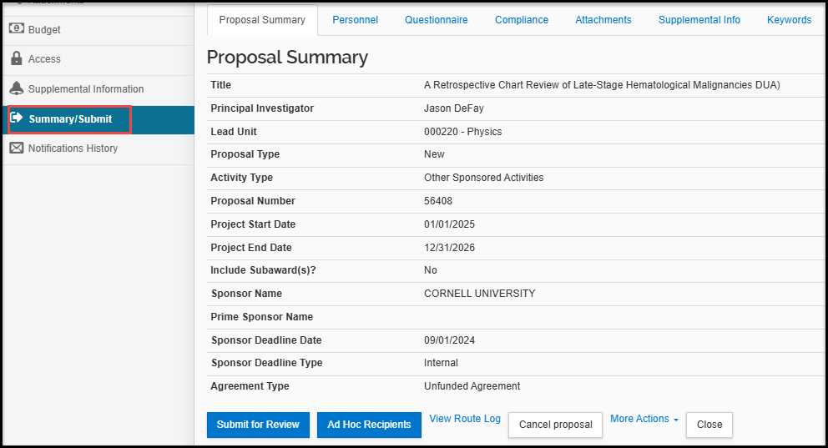
Click on Submit for Review (You may receive a Data Validation pop-up indicating you have Errors and/or Warnings. You will need to “fix” the Errors).
NOTE: You will also receive Warnings. Warnings do not prevent you from submitting your Unfunded Agreement and no action is required.
Click on Fix it next to the red Error button. It will take you to the page with the error that needs to be fixed.
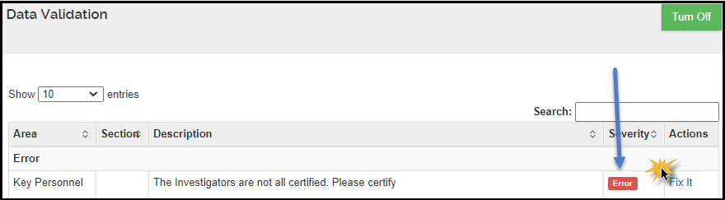
- Click on Submit with Warnings.

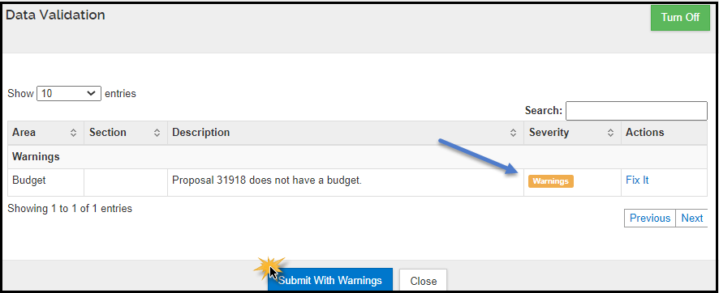

Once Submit for Review is clicked, the request will route for approval. If more edits need to be made after the request has been submitted but before it has been approved, a Recall button is available. Clicking the Recall button will allow you to make edits to the request then submit again for review.

Notifications History
The Notifications History screen is where Kuali system generated notifications are listed, including the Principal Investigator certification notification. Each notification listed will note the Date Created, Recipients, Subject, and Message content.
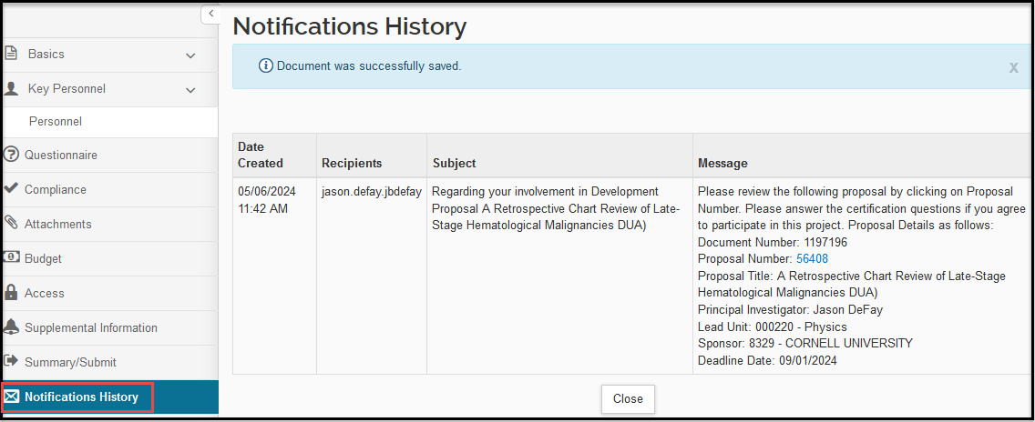

Exhibit A – Confidentiality /Non-Disclosure Agreements (CDA/NDAs)

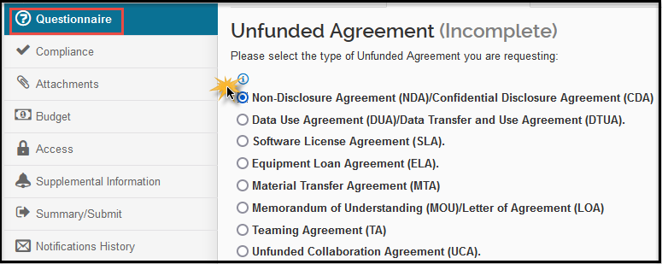
- A non-disclosure or confidentiality agreement is intended to cover conversations that contain confidential and/or proprietary information or the exchange of such information from one or more parties and the contractual terms dictate the authorized disclosure, receipt, and use of the information.
- Commonly, a CDA/NDA is put in place when the other entity/institution and a principal investigator are contemplating a research collaboration but first needs to exchange information to further evaluate the potential for such a collaboration.
- If prior disclosure is not necessary (ex. evaluation of a potential collaboration can be made without exchanging any proprietary information), no CDA/NDA is needed, and appropriate non-disclosure/confidentiality terms will be incorporated into the actual research or collaboration agreement.

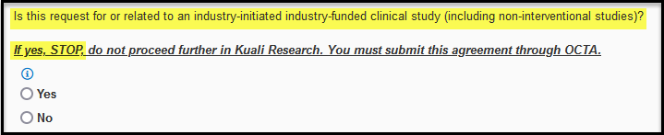
These CDAs permit UCSD to receive an industry partner’s study/master protocol to determine interest and feasibility in participating in an industry-initiated, industry-funded clinical trials, and are managed by OCTA.

If yes, initiator should stop with the PD record and submit to OCTA via their jotform

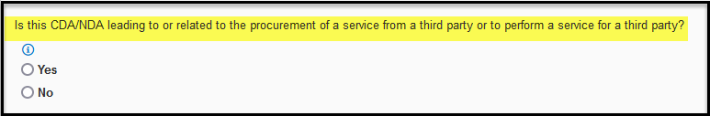

These CDAs are preparatory to a potential future service agreement or Purchase Order where UCSD is paying an entity to perform a service for us (ex. to obtain a vendor’s quote for services).

- If yes, and General Campus, continue with the submission.
- If yes, and Health Sciences, then STOP the submission and contact HS BC.
- If no, then STOP with submission and reach out to Procurement.

Exhibit B – Data Use Agreement (DUA)/Data Transfer Use Agreement (DTUA)
If you are sharing non-human subjects data, please select “Unfunded Collaboration Agreement (UCA)”

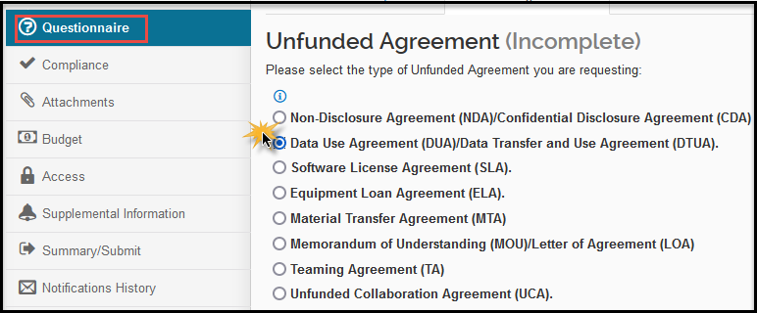
- A Data Use/Transfer Agreement allows one or more party(ies) to provide access to, or transfer of, data to or from a UCSD principal investigator for research purposes.
- A mutual DUA can also be negotiated to allow UCSD and the other party(ies) to exchange data.
- The DUA will provide appropriate protection of the data from unauthorized disclosure or use, or under applicable laws (such as HIPAA for human subjects data), while still ensuring UCSD’s ability to publish its research results or to share them for academic purposes.
- Data use terms may also be included within a larger agreement context, such as a sponsored or collaborative research agreement, so a DUA is commonly negotiated for “standalone” projects where the primary focus is the data itself. If there is another agreement covering the research, please let OCGA know so that they can evaluate whether a separate DUA is still needed.

This must be correctly answered, or the PD record will be returned to you for corrections.

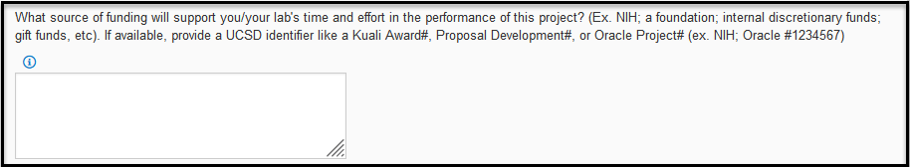

While UCSD is not receiving funding for this project/agreement, the university needs to ensure that there are no conflicting sponsor obligations (ex. if you generated data under Gates Foundation funding but now want to share it with Pfizer, we need to check whether that is possible under the Gates Foundation award). For most agreement types, a fund source is required. Examples include federal grants, industry or non-profit funding, gift funds, or unrestricted internal funds. Please provide a university identifier such as the Kuali PD/IP/Award # or the Oracle Project number.

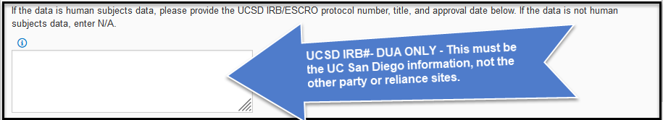

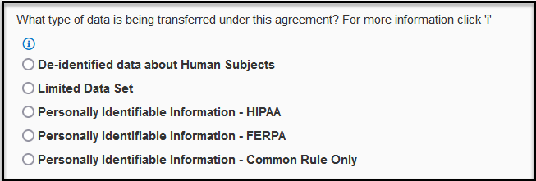

Definitions:
- De-identified data about human subjects: data collected from or about human subjects that are scrubbed of all 18 HIPAA identifiers. This can include data collected under standard of care.
  - UCSD requires a DUA for outgoing de-identified data.
- Limited Data Set: a set of identifiable human subjects information as defined by HIPAA. This can include data collected under standard of care. Most of the 18 identifiers (direct identifiers) must be removed; only the following may remain:
  - dates such as admission, discharge, service, DOB, DOD
  - city, state, five digit or more zip code; and
  - ages in years, months or days or hours
- Personally Identifiable Information - HIPAA: Protected Health Information or “PHI” including any of the direct identifiers as defined by HIPAA. This can include data collected under standard of care.
- Personally Identifiable Information - FERPA: identifiable information contained in educational records as defined and protected by the Family Educational Rights and Privacy Act (FERPA)
- Personally Identifiable Information - Common Rule Only: identifiable information collected from individuals who are the subject of research projects.

For more information: HIPAA Privacy Rule vs. Common Rule

Exhibit C - Software Loan Agreement

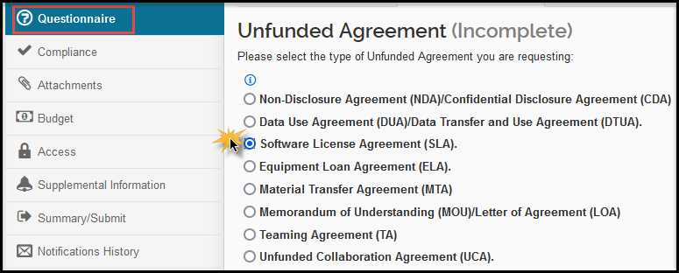
Note: Agreements may be processed by UCSD Procurement & Contracts if there is a recurring payment to the other party AND the other party is loaning the software to UCSD without requesting any evaluation.

- A Software Licensing Agreement allows for an outside party to provide use of software to UCSD for research purposes, providing both parties mutual benefit from use of software by UCSD.
- Separate software licensing agreements are generally only negotiated in cases where a company is providing software only and there is no other research support (e.g., no funding).
- If the software is being loaned/provided as a part of a research project funded by the party providing the software or as part of an unfunded collaboration, the licensing terms should be included as part of the research or collaboration agreement.

Funding Source:
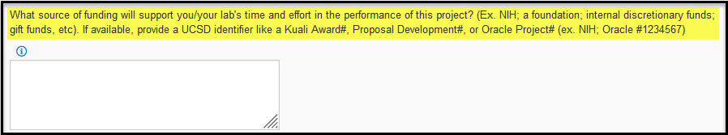

While UCSD is not receiving funding for this project/agreement, the university needs to ensure that there are no conflicting sponsor obligations (ex. if you are receiving software from Intel for a project under SRC funding, we need to check whether there are additional requirements from SRC). For most agreement types, a fund source is required. Examples include federal grants, industry or non-profit funding, gift funds, or unrestricted internal funds. Please provide a university identifier such as the Kuali PD/IP/Award # or the Oracle Project number.

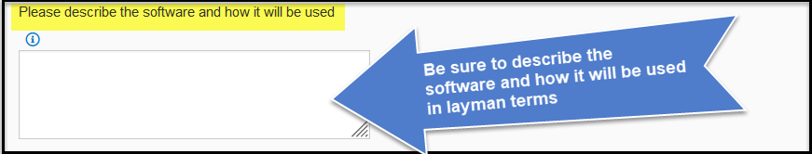

Exhibit D - Equipment Loan Agreement

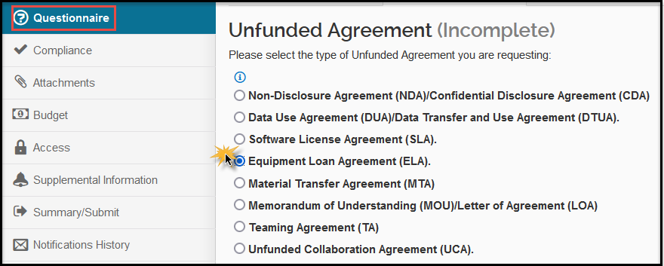
Note: Agreements may be processed by UCSD Procurement & Contracts if there is a recurring payment to the other party AND the other party is loaning the software to UCSD without requesting any evaluation.
An Equipment Loan Agreement is usually an agreement between UCSD and another party that allows that party to loan one or more items of equipment to UCSD for research purposes.
- Separate equipment loan agreements are generally only negotiated in cases where a company is providing equipment only and no other research support (e.g., no funding).
- If the equipment is being loaned/provided as a part of a research project funded by the party providing the equipment or as part of an unfunded collaboration, the loan terms should be included as part of the research or collaboration agreement.
- Loaned equipment is not automatically covered by the UCSD insurance program, be sure to confirm if and how the loaned equipment will be covered.
Funding Source:

While UCSD is not receiving funding for this project/agreement, the university needs to ensure that there are no conflicting sponsor obligations (ex. if you are receiving software from Intel for a project under SRC funding, we need to check whether there are additional requirements from SRC). For most agreement types, a fund source is required. Examples include federal grants, industry or non-profit funding, gift funds, or unrestricted internal funds. Please provide a university identifier such as the Kuali PD/IP/Award # or the Oracle Project number.
ECCN Number:
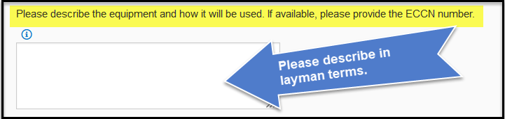
Please look over the ECCN 1C351 list for any export restricted biological items.

Exhibit E – Material Transfer Agreement
ADDGENE requests do not require a Kuali Record. Using this link to take you to the Addgene Request Form:
https://forms.raleyapps.com/form/render/b464db1a-5068-4722-ad0c-feea22ef8c77/0ffyvf2tlh

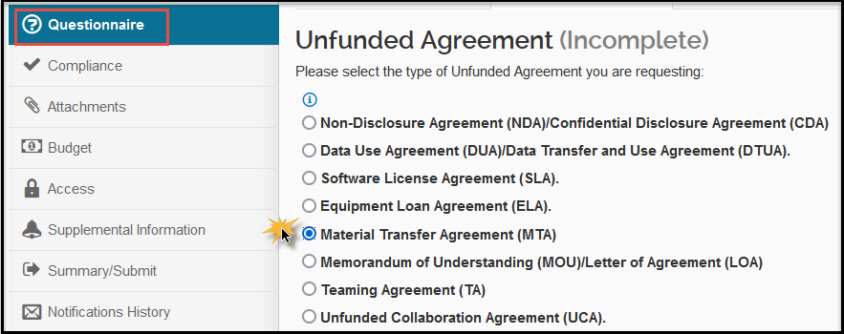

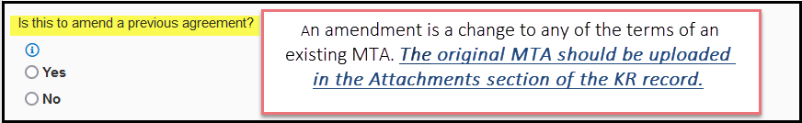

Third Party Material:

Third-Party Material' means material that was provided to your current UCSD lab (whether by purchase, transfer, 'gift', collaboration, relocation, or agreement) from a source that is outside of your current UCSD lab.

Bi-Directional Material:

If the agreement includes sending Bi-Directional materials (UCSD is sending material to the contracting entity, and the contracting entity is sending UCSD material, you will need enter the information in the Comments Section in detail.
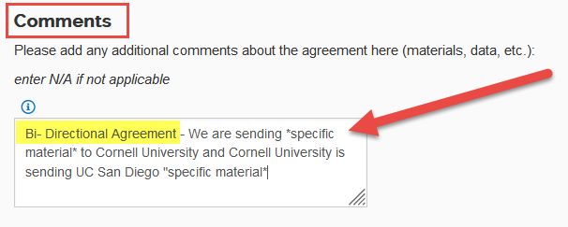

Exhibit F – Memorandum of Understanding/Letter of Agreement

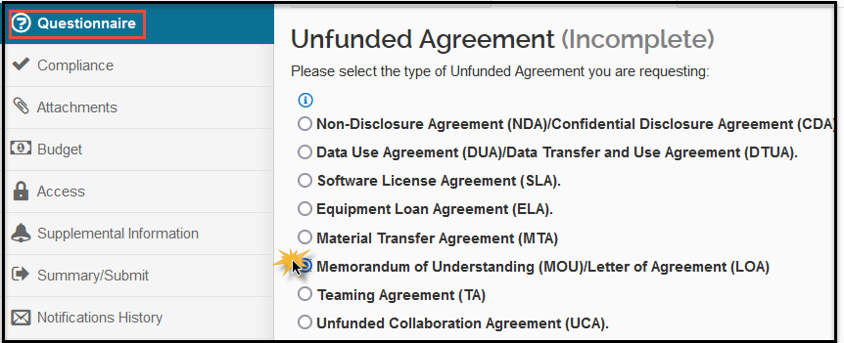
The Office of Global Initiatives facilitates UCSD’s international engagement by developing MOUs with institutions around the world. If you have an international MOU, please see Global Initiatives’ Decision Tree to see which office should handle it.

- Commonly, these are agreements between two or more parties that function as a more formal alternative to a verbal or "handshake" agreement but are not intended to be legally binding.
- In the research community, MOUs often act as a letter of intent to indicate a common interest in pursuing similar research goals or a future partnership; however, such intentions may not have progressed to the point where the parties are prepared to make a formal commitment.
- However, depending upon the wording and the intent of the parties, a MOU may have the power of a binding contract.
- “MOU” is also a broad title that is often used by companies or foreign institutions on agreements that UCSD would categorize as a research collaboration or a different type of unfunded agreement (CDA if it permits the transfer of proprietary information, DUA if it contemplates the transfer of data, etc.). In KR PD, the initiator should select the category of unfunded agreement that describes the activity that is taking place, rather than the title of the document, to ensure that appropriate compliance reviews occur.

Exhibit G – Teaming Agreement
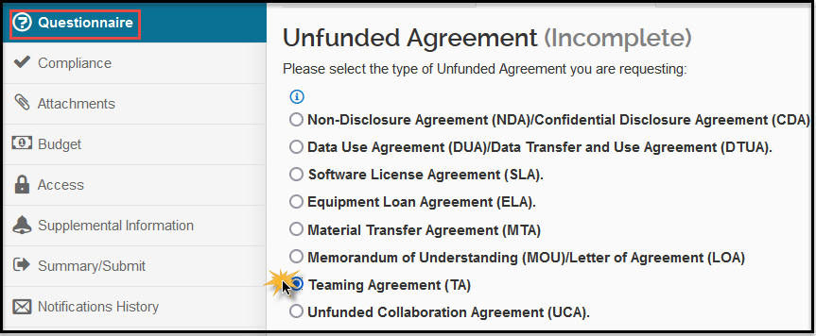
- A Teaming Agreement formally acknowledges the relationship and participation of two or more parties who are submitting a proposal for research funding to an outside sponsor, such as the Federal government.
- It establishes the purpose of each party's participation and which of the parties will be primarily responsible for submitting the proposal and receiving the award, and which party will receive a subaward(s) from the party receiving the award.
- If you are working with a small business to apply for federal funding under the SBIR/STTR mechanisms, the small business may ask to put in place an intellectual property agreement or allocation of rights agreement. Those are not teaming agreements and often are not a required component of the proposal application; instead, it is sufficient to tell the federal agency that, if awarded, UCSD and the small business will enter into an agreement that covers intellectual property and the allocation of such rights. Please double check with the RFP to see if such an agreement is required at the proposal stage.

Exhibit H – Unfunded Collaboration Agreement

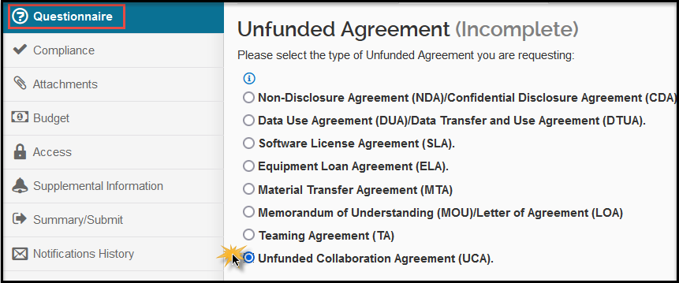
If this project involves the transfer of tangible research materials, submit the request as an MTA rather than a UCA.

- An unfunded collaboration agreement is akin to a standard research collaboration but there is no transfer of funds between the parties. Each party generally funds its own portions of the research.
- These collaborations can include the transfer of data or materials, but both parties are generally performing the research. If you are only receiving or only providing materials/data/etc. and are not performing part of the research, submit the PD record as one of the other agreement types.
Funding Source:

While UCSD is not receiving funding for this project/agreement, the university needs to ensure that there are no conflicting sponsor obligations (ex. if you are receiving software from Intel for a project under SRC funding, we need to check whether there are additional requirements from SRC). For most agreement types, a fund source is required. Examples include federal grants, industry or non-profit funding, gift funds, or unrestricted internal funds. Please provide a university identifier such as the Kuali PD/IP/Award # or the Oracle Project number.

